
Anatomy & Physiology Lesson 2 Exam
Please read these instructions before you begin to answer the questions that follow.
You are welcome to work your answers on this paper examination for your convenience. You will submit your final answers through an uploaded file through our app. When you are satisfied that your answers are correct, use the app to download an instruction file for the corresponding lesson. This will open the lesson, so you are able to add your work for grading. Complete this file upload for grading. Only the answers on the submitted file will be considered for grading.

You have reached the end of Lesson 2 and are ready for your Lesson 2 Examination. After you complete it, log in and submit through the app. Good luck!

Instructions:
Follow the instructions for each question. Show your work in the space provided and write the answer on the line. You will need to show your work on the file submitted to your teacher for grading.
Multiple Choice (worth 2 points each): Enter your selected answer into the blank space provided.

_____1. Which of the following is NOT a function of bones?
  - The first layer of defense against pathogens.
  - Surrounds and supports delicate internal organs.
  - Site of hematopoiesis.
  - Participates in the release of energy from stored fat.

_____2. Which grouping below are examples of long bones?
  - tibia, femur, and vertebra
  - phalanges, ulna, and humerus
  - metacarpals, skull, and metatarsals
  - occipital, front, and temporal

_____3. What is a major concern astronauts have during extended space travel?
  - bone shortening due to the change in gravity
  - increase in bone density
  - reduced levels of hematopoiesis
  - decrease in bone mass and strength
_____4. Which fracture type is more common in children and is classified as an incomplete
break?
  - comminuted
  - simple
  - greenstick
  - compound

_____5. Which spinal region connects to the ribs?
  - thoracic
  - lumbar
  - sacral
  - cervical

_____6. Which bone is always on the “little finger side” of the forearm?
  - humerus
  - radius
  - ulna
  - tibia

_____7. Which of the following are functions of the articular cartilage?
  - Cushions the joint
  - Reduced wear to the joint
  - Reduces friction to the joint
  - All of the above

_____8. True or False: People can be three quarters of an inch taller when they rise in the morning
  - True
  - False

_____9. Collectively, which bones function as a sight of muscle attachment for many of the arm muscles? They allow for a wide range of motion in the arms.
  - xiphoid process and costal cartilage
  - manubrium and humerus
  - clavicle and scapula
  - none of the above

_____10. Which bone disorder is associated with reduced bone strength and crush-type fractures of the vertebral column?
  - sprain
  - fracture
  - bursitis
  - osteoporosis

_____11. Which muscle tissues are involuntary?
  - smooth muscle tissue
  - skeletal muscle tissue
  - cardiac muscle tissue
  - both A and C

_____12. A nerve that stimulates skeletal muscles is called a(n)____________.
  - motor neuron
  - parallel nerve
  - axon terminal
  - sarcomere

_____13. Which muscle aid in breathing by expanding the thoracic cavity during inhalation?
  - Intercostals
  - Diaphragm
  - Obliques
  - Trapezius

_____14. Which of the following is associated with muscular dystrophy?
- protrusion of the abdominal cavity
- muscle that progressively becomes weaker
- weakened abdominal muscles
- both a and c

Use the figure below to answer questions 15-17.
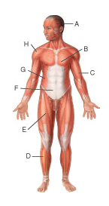
_____15. The structure labeled C above is the
  - temporalis.
  - tibialis anterior.
  - external oblique.
  - bicep brachii.

_____16. Which structure is responsible for raising the eyebrows?
  - A
  - D
  - F
  - G

_____17.Which labels correspond to muscles of the trunk?
  - H and A
  - C and B
  - G and F
  - F and B

_____18. Which of the following may be a cause of cramps?
  - electrolyte imbalance
  - dehydration
  - deficiency in mineral such as calcium or potassium
  - all of the above

_____19. The ability of a muscle and other tissue to be stretched is the behavioral characteristic known as _______________.
  - extensibility
  - elasticity
  - irritability
  - contractility

_____20. The fixed structure where a muscle attaches is the ___________.
  - insertion
  - origin
  - tendon
  - fixture

_____21. Which nervous system controls skeletal muscle movement?
  - somatic nervous system
  - autonomic nervous system
  - parasympathetic nervous system
  - sympathetic nervous system

_____22. Which glial cell absorbs and gets rid of dead cells and bacteria?
  - oligodendrocytes
  - ependymal
  - microglia
  - astrocytes

_____23. Some factors that can influence the speed of a nerve impulse are _______________.
  - body temperature
  - diameter of the axon
  - presence of myelin sheath
  - all of the above

_____24. What is a rapid and involuntary response to a stimulus?
  - reflex
  - action potential
  - conduction
  - refractory period

_____25. What is the correct order of protective meninges from skull to brain?
  - arachnoid mater, pia mater, and dura mater
  - dura mater, pia mater and arachnoid mater
  - pia mater, dura mater, and arachnoid mater
  - dura mater, arachnoid mater, and pia mater

_____26. The _____ (is) are) the raised area of the brain
- sulcus
- gyrus
- white mater
- lobe

Use the image below to answer questions 27-30.
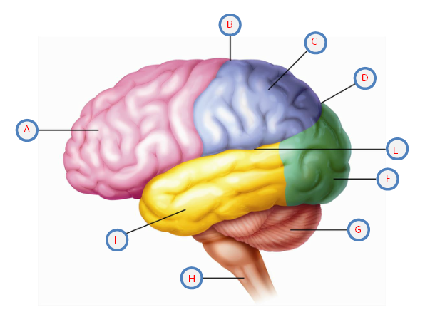
_____27. Which structure above represents the occipital lobe?
  - A
  - D
  - F
  - I

_____28. Which structure labeled above is responsible for behavior, intelligence, emotions, memory, and much more?
  - A
  - D
  - G
  - H

_____29. The structure labeled E above is the ____________.
  - parieto-occipital sulcus
  - frontal lobe
  - lateral sulcus
  - cerebellum

_____30. What is the function of the structure labeled G above?
  - motor impulses
  - breathing
  - hormone secreting
  - balance

Labeling (worth 14 points total) Use the diagram below to answer question 31.

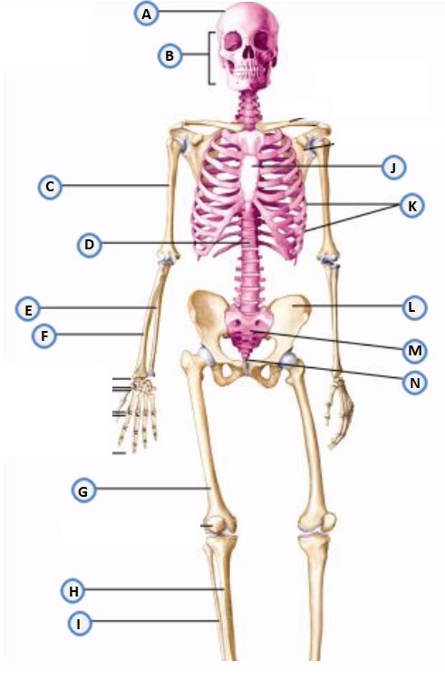
31. Use the following word bank to match the correct axial or appendicular skeleton part with the corresponding letter above.
Word Bank:
___ Ulna | ___ Ribs | ___ Facial Bones | ___ Scapula | ___ Spine
___ Tibia | ___ Sacrum | ___ Femur | ___ Cranium | ___ Sternum
___ Coxal Bone | ___ Humerus | ___ Fibula | ___ Coccyx | ___ Radius

Matching (worth 10 points, 1 point each)
32. Match the terms in Column I with the descriptions in Column II.

Column I Column II

arthritis a. Joint inflammation associated with age
sprain b. low bone mineralization and strength
osteoporosis c. caused by running on hard surfaces or uphill
contusions d. balloon-like protrusions from the abdominal muscles
shin splints e. symptoms include motor function impairment
muscular dystrophy f. repeated seizures over time
hernia g. inflammation of the meninges
cerebral palsy h. overstretching of ligaments or tendons
meningitis i. bruise or bleed in the muscle
epilepsy j. progressive muscle weakness and muscle tissue loss

Essays (worth 16 points, 8 points each)
33. Imagine you are playing baseball and a line drive comes out of nowhere. You do not even realize till the last second that it is heading for your face! Explain the reflex type of movement you would experience. Describe the nervous system’s reaction from sensing the stimuli to response.
________________________________________________________________________________________________________________________________________________________________________________________________________________________________________________________________________________________________________________________
____________________________________________________________________________________________________________________________________________________________
____________________________________________________________________________________________________________________________________________________________
____________________________________________________________________________________________________________________________________________________________
____________________________________________________________________________________________________________________________________________________________
____________________________________________________________________________________________________________________________________________________________
____________________________________________________________________________________________________________________________________________________________
____________________________________________________________________________________________________________________________________________________________
____________________________________________________________________________________________________________________________________________________________

34. The movement of the muscles are divided into different planes or directional motions. Keep the movements of muscles in mind as you answer the questions below:
  - Imagine you are trying to write your name without using your thumb. Why is opposition important?
  - Flexion is movement in the sagittal plane. What areas of the body are affected by flexion? If all of these joints that perform flexion do so at the same time, what position are you in? Be sure to include a general description of flexion motion.
________________________________________________________________________________________________________________________________________________________________________________________________________________________________________________________________________________________________________________________
____________________________________________________________________________________________________________________________________________________________
____________________________________________________________________________________________________________________________________________________________
____________________________________________________________________________________________________________________________________________________________
____________________________________________________________________________________________________________________________________________________________
____________________________________________________________________________________________________________________________________________________________
____________________________________________________________________________________________________________________________________________________________
________________________________________________________________________________________________________________________________________________________________________________________________________________________________________________________________________________________________________________________

